Allstars Unit Full Circle
In Person Party Guide
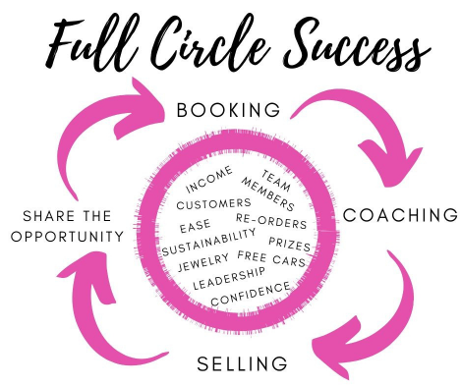
Debra Allison, Senior Sales Director
612.810.2303 cell/text
763.449.0948 office
www.DebraAllison.com
allison.mark@comcast.net

Full Circle In Person Party Outline
Pre-party starting:
-When guests arrive, do the Satin Hands treatment on each guest. Establish relationships and talk to your guests!
-Guide them to the table when everyone is done and have them fill out their profile cards.

The Party: (areas in bold are most important for full circle success!)
1. Thank everyone for coming
2. Have everyone say their name, what they do, and something they'd like to learn about skin care or color
3. Give agenda and let them know at the end, even if they don't want to purchase anything, you'll still WANT TO MEET WITH THEM in the hostess's “executive suite” in her living room to get feedback and answer questions
4. Tell your story-how you got into MK, why you are doing it and where you're going. At the end say "Watch me tonight and see if you could ever see yourself doing what I do"
5. –Explain the rules and start What’s in my Bag!
6. If doing a Skin care or a color-use your flipchart
7. Play the REFERRAL GAME!
8. Start your Timewise 3D Miracle Set or TimeWise Volu-Firm Repair Skincare (or color session) Session
9. After Cleansing & moisturizing match and apply CC Cream on each guest – COMPLIMENT TIME-when cc cream is done. Have them turn to each other and say what they like best about each other's new looks.
10. One more game - Play Deal or No Deal
12. Show them the sets on the SKIN CARE set sheets that are on the Placemats that came in your kit. Be sure to visually pull the bottles out again and show the Miracle Set & Ultimate Miracle set. Let them know how to pay and if you have products on hand.
13. INDIVIDUAL CONSULTATIONS This is where you will sit down with each guest in the “executive suite” away from the facial table, to ask her these questions.
- Did you have fun today?
- How does your skin feel?
- If you could take everything home with you that we tried today, is there any product you could see yourself not using?
- What would you like to start with today? (give her 1 of 2 set options) and then continue asking “What about the (another product she tried and seemed to like) keep suggesting until she says No, that will be all. Write up her sales slip, add the tax and get payment. Make sure to book her for her second appointment. Was she a Deal or No Deal gal. If she said No Deal, then be sure to say “Have you changed your mind about getting together for your second appt? “I like you; I think you’re really fun”. “I would love to get together with you for (color/spa/hydration session)” and then see what she says.
- If she said YES she changed her mind or is a Deal gal get her on your calendar right then and there.

Supplies you'll need to print:
All Documents are available to download and print on www.debraallison.com/Education/InPersonBeautySessions

Deal or No Deal:

How To Play What’s in My Bag:

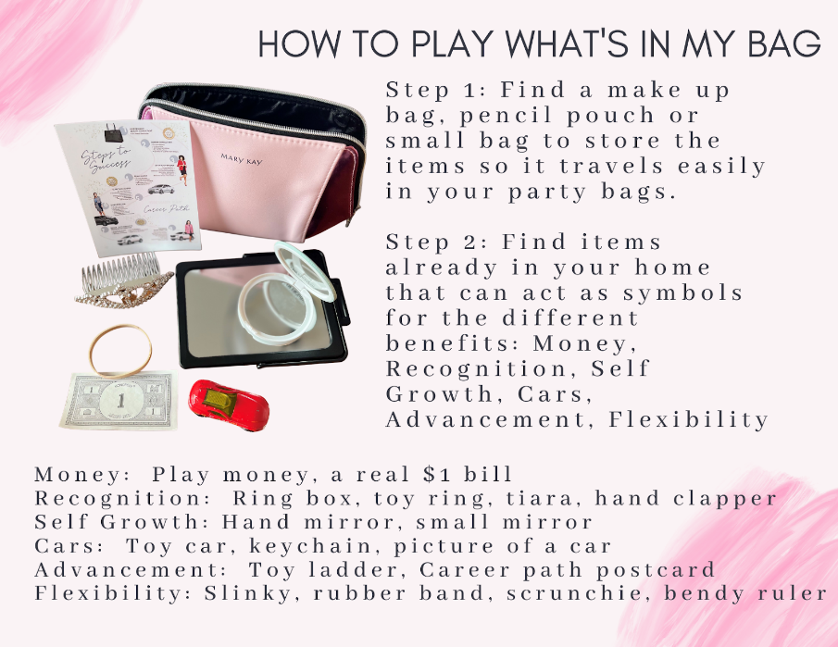
Steps To Success Card:
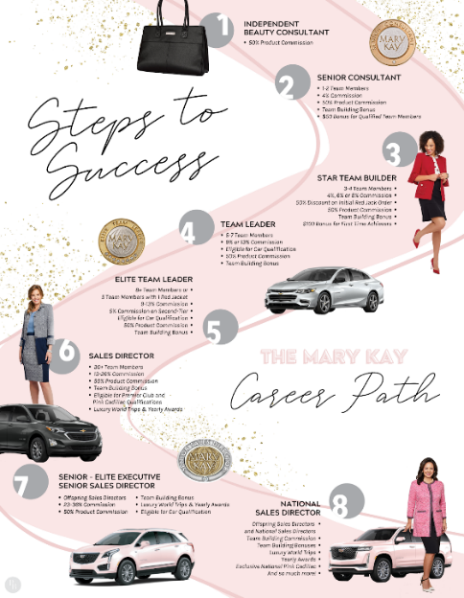

We Value Your Feedback forms:

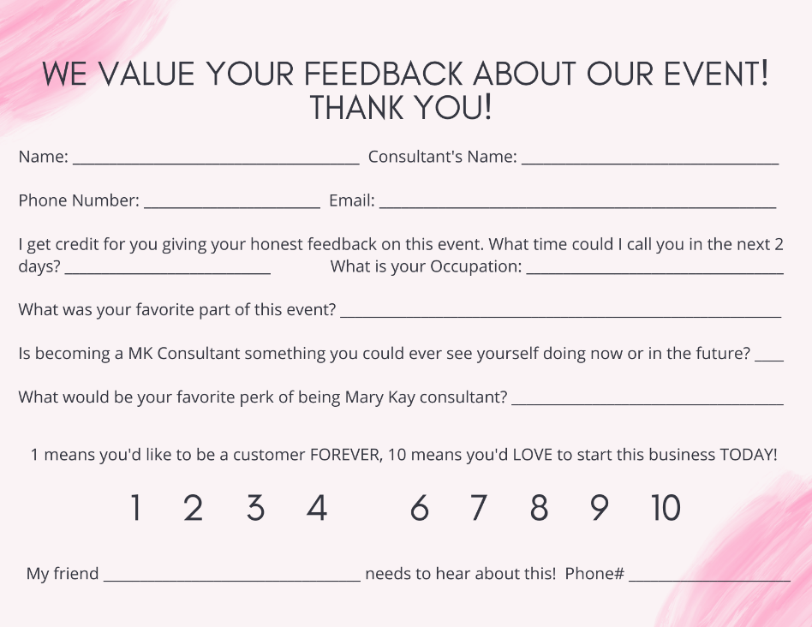

* We Value Your Feedback Form Google Link: save this to your phone so you can copy and paste it to everyone in a text. https://forms.gle/w7YoR5AUzNupnjqs8

* Insert Cards for Trays: can be found on your Mary Kay order under section 2. Under Supplies-Packaging/Party Supplies/ Tray Inserts part #: 173194

ALLSTAR UNIT Referral Game
After skin care, I have my guests apply the Satin Lip scrub. Then I set up the game!
We are going to play a fun game! How many of you have ever seen a TV Commercial, Billboard or a magazine with Mary Kay in it?? It's kind of a trick question--we don't advertise a lot because Mary Kay wanted that one on one relationship with our customer and to keep corporate costs low so she could offer so many fun incentives like practically career cars to the sales force!
On the back of your profile card is the fabulous game. Because we don't advertise a lot, I work a lot based on referrals. I'm going to give you 3 min to think of anyone you know who is overworked, under-pampered and under-appreciated and could use some pampering with Mary Kay. I text or call and offer them with Mary Kay not scary Kay-I won't stalk your friends. There are some rules to this game....
1. You can use your phone! It isn't cheating
2. They must be 18 or older
3. You only have to write their first name-you probably won't win the race if you write their last names.
(If they start writing say, " I haven't said go yet lol")

Everyone who gives me 20 will get a goodie bag with a sample and a purse sized Satin Hands cream, but the FIRST person to get to 20 gets a free mascara of their choice from me!

READY....SET...….GO!

Emily Schuette, Sales Director
ALLSTAR UNIT Deal or No Deal Booking parties from parties
After the dash out the door color card, I have them compliment each other on their new looks and then say "We’re going to play two corny games, I'll show you some deals, and then we're done!
The first game is "deal or no deal". Tonight was our first date together, and if you enjoyed our date and you want to book a second one to try other products we're doing that now.
Maybe you want to do a full glam look, spa night with PJ's, or a multi-masking class – you get to pick your treatments. I'm going to come around and ask each person "DEAL....OR....NO DEAL". If you say "no deal" it means you don't want to book that second appointment...and just so you know, if you say "no deal" I'll still appreciate and like you anyways (lol), if you say "deal" it means you want to book that second appointment either at your home or at one of my makeover events.
When you share it with at least 2 new friends over 18 that I haven't met before, you’ll get a shopping spree of $40 off a purchase of $75 or more. PLUS, you'll get extra product bonuses on the back of one of my cards (tell them what the bonuses are).
Start with the person you think is excited to say yes: Ask her "Jane....DEAL or NO DEAL". If she says deal, BE EXCITED! If she says, no deal then say, “No problem, my friend, if you change your mind, just let me know! It would be fun to get together with you again!”
At the end of the game say "Thanks for playing, if you said DEAL we'll work together when we meet individually to figure out when you'd like to do it!"
Emily Schuette, Sales Director

ALLSTAR UNIT-How To Play
‘What’s In My Bag’
This is a great game to play at all of your appointments to share the Mary Kay information.
Step 1: Find a makeup bag, pencil pouch or small bag to store your items so it travels nicely in your party bags.
Step 2: Find items already in your home that symbolize the following benefits: Money, Recognition, Self Growth, Cars, Advancement/Advantages, Flexibility (see suggestions below)
Money: play money or a $1 bill
Recognition: Ring box, toy ring, tiara, hand clapper
Self Growth: Hand mirror, small mirror
Cars: Toy car, keychain, picture of car
Advancement: Toy ladder, career path postcard
Flexibility: Slinky, rubber band, scrunchie, bendy ruler
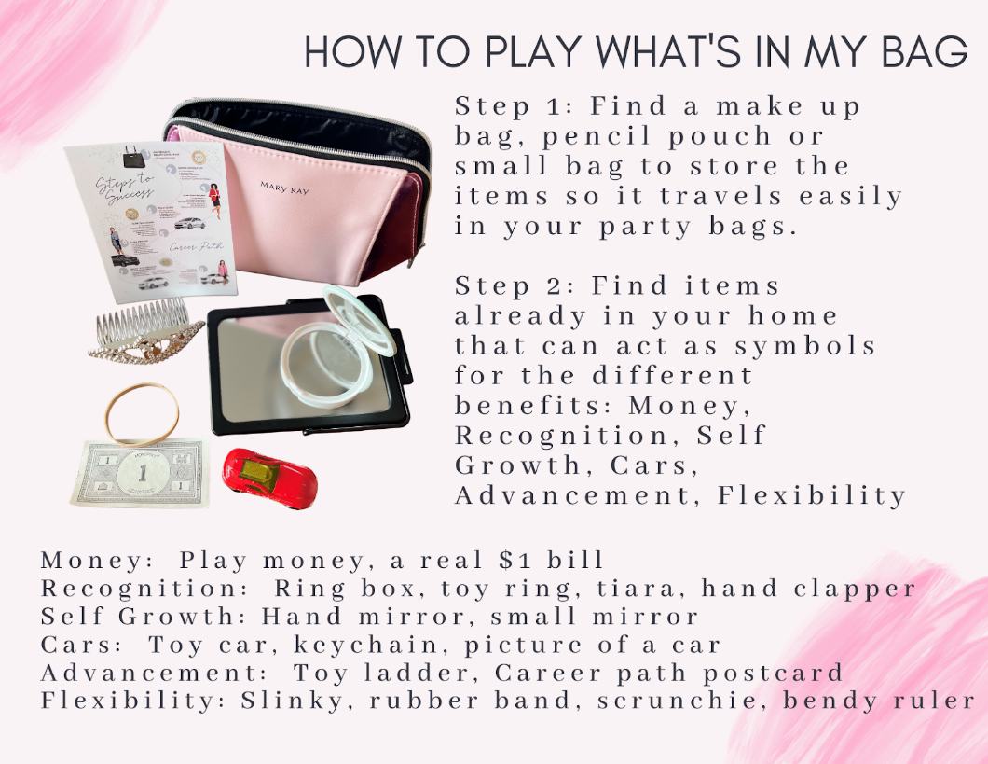

ALLSTAR UNIT-Adding Team Members @ Parties
Step 1: Tell your I-story at the beginning of the party. At the end say "watch me tonight, see if you could EVER see yourself doing what I do. Also, so you aren't wondering the entire night, it's either $30 or $130 + tax & shipping to start MK! (show options sheet & talk briefly about them)
Step 2: After Deal or no Deal for bookings, play either the Purse Game or What's in my Bag. Each game goes over the MRS CAB information: M=Money, R=Recognition, S=Self confidence, C=Car, A=Advantages/advancement, B=Be your own boss/ flexibility
Supplies that are helpful to have on hand: Starter kit flier, Car flier
Step 3: Have everyone fill out the 1-10 form with feedback on it. Document is on www.debraallison.com/Education/InPersonBeautySessions
Step 4: In the individual consultation at the end of the party:
1. Write up/finalize what she's buying and book her second appointment
2. Ask "I see you were a __ on the interest scale, tell me about that" (keep asking her what reasons would be FOR doing it)
3. Ask "besides that feeling of when you start something new (insert example of discomfort of starting a new adventure) and everything that is uncomfortable and uncertain for the first couple weeks, what would it take for you to go from a ___to a 10 on the scale? (again, listen and answer questions)
4. Ask her if she wants to join your team, say "I had a blast with you tonight & would love to work with you, you seem excited about it--what are YOU thinking? When she says yes, have her order the eStart or Starter Kit!

ALLSTAR UNIT-What to Say About the Opportunity at Parties
What’s IN MY BAG: Tell your guests "I want each person to take one thing out of this bag that interests you, hold onto it and pass the bag on." Once they all have an item: "Each one of these items represents a benefit of being a Mary Kay consultant. Now you're going to say what your item is, and guess that benefit.
Money: Most Americans have a "side hustle", there's so much power in having the ability to generate $. If you needed $500 by next week, could you get it? We make our money in 3 ways- 1. Selling the products, we make 50% of what we sell. The better you are at relationships the more you sell--women won't purchase and re-order from pushy sales people. 2. Adding people to our teams. Mary Kay isn’t a multi-level marketing, we don't get paid just for signing people up. We get paid based on how well people are doing, so it's a women helping women system. 3. Leadership-Anyone can become a sales Director, you work your way into it. I'm finding more women are wanting leadership because even if they love their job, there's maybe nowhere else to go. Leaders make anywhere from a decent corporate equivalent income to over six figures.
Recognition: Mary Kay believed that women would ultimately work harder for appreciation than they would for even money. If you ever have seen one of our success mingles, there's clapping and hugging and music so we can recognize people! We also get a ton of prizes—there’s some quarterly prizes like (name some), diamonds you can earn at seminar, and trips around the world (talk about some).
Self-Confidence: We say Mary Kay is a personal growth course you get paid to take. We teach you business skills, how to wear makeup/present, personality testing, and everything helps to increase your confidence in a supportive environment. Many women use Mary Kay as a vehicle to increase their confidence!
Cars: You can earn the use of a Career Car that is practically free! Does anyone know the most famous one?-THE PINK CADILLAC! (pull out and pass one to all the Chevy Malibu, Chevy Equinox, and Cadillac flier) We also have the Chevy Malibu & the Chevy Equinox. They pay for most of your car insurance, all of your license and tabs. Imagine your budget if you weren't making a car payment? Shout out some things you'd do with that cash? You can also take the option of $425, $500, or $900 cash per month! WHO WOULD TAKE CAR? CASH?
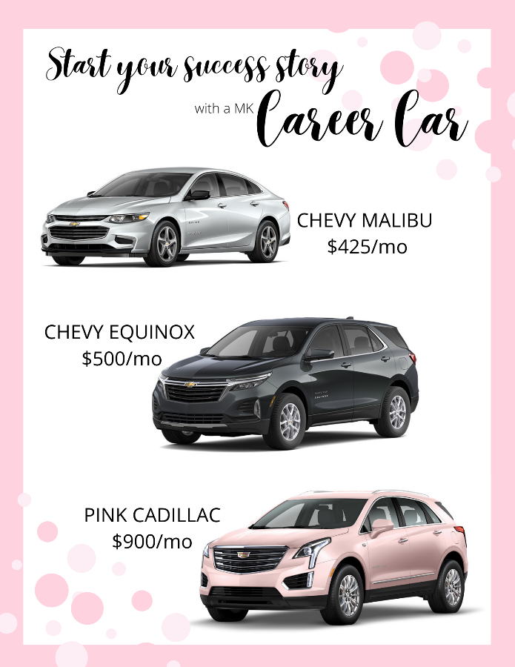
Advantages/Advancement: Mary Kay is not a get rich quick thing (that doesn't exist, right?) you get out of it what you put into it! Isn’t that exciting? Nothing else matters--education level, age, how long you've been in. It's so neat to see so many women from different backgrounds that are successful. We also have advantages like no quotas, no territories, tax deductions, free training/mentorship.
Be your own boss/flexibility: Most consultants do an average of 2-6 hours a week, which would be one appointment like this per week. It’s totally based on your goals! If you wanted to earn that first career car you're probably looking at around 10-15 hours per week. The point is that you don't need big chunks of time, you can weave it into what you're already doing!

Then say,
I have a 1-10 Survey Form that I would like for you to fill out (you can offer an incentive if you like for them to do so like $5 off their order. You can also tell them you have a goal to have X number of these filled out each week). “1” means I’d like to be a customer FOREVER and “10” means I’d love to start this business today, and “5” is cheating so that is why it’s not on the form! (lol)

