ALLSTAR UNIT-
What To Say – Team Build
How To Play
‘What’s In My Bag’
This is a great game to play at all of your appointments to share the Mary Kay information.
Step 1: Find a makeup bag, pencil pouch or small bag to store your items so it travels nicely in your party bags.
Step 2: Find items already in your home that symbolize the following benefits: Money, Recognition, Self Growth, Cars, Advancement/Advantages, Flexibility (see suggestions below)
Money: play money or a $1 bill
Recognition: Ring box, toy ring, tiara, hand clapper
Self Growth: Hand mirror, small mirror
Cars: Toy car, keychain, picture of car
Advancement: Toy ladder, career path postcard
Flexibility: Slinky, rubber band, scrunchie, bendy ruler
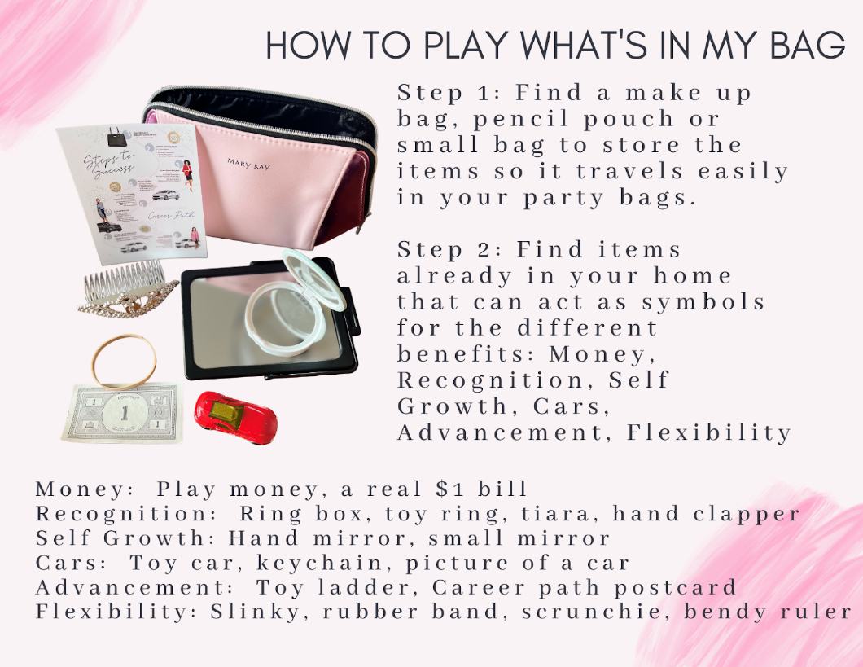

ALLSTAR UNIT-Adding Team Members @ Parties
Step 1: Tell your I-story at the beginning of the party. At the end say "watch me tonight, see if you could EVER see yourself doing what I do. Also, so you aren't wondering the entire night, it's either $30 or $130 + tax & shipping to start MK! (show options sheet & talk briefly about them)
Step 2: After Deal or no Deal for bookings, play either the Purse Game or What's in my Bag. Each game goes over the MRS CAB information: M=Money, R=Recognition, S=Self confidence, C=Car, A=Advantages/advancement, B=Be your own boss/ flexibility
Supplies that are helpful to have on hand: Starter kit flier, Car flier
Step 3: Have everyone fill out the 1-10 form with feedback on it. Document is on www.debraallison.com/Education/InPersonBeautySessions and also under Education/Important Links
Step 4: In the individual consultation at the end of the party:
1. Write up/finalize what she's buying and book her second appointment
2. Ask "I see you were a __ on the interest scale, tell me about that" (keep asking her what reasons would be FOR doing it)
3. Ask "besides that feeling of when you start something new (insert example of discomfort of starting a new adventure) and everything that is uncomfortable and uncertain for the first couple weeks, what would it take for you to go from a ___to a 10 on the scale? (again, listen and answer questions)
4. Ask her if she wants to join your team, say "I had a blast with you tonight & would love to work with you, you seem excited about it--what are YOU thinking? When she says yes, have her order the eStart or Starter Kit!

ALLSTAR UNIT-What to Say About the Opportunity at Parties
What’s IN MY BAG: Tell your guests "I want each person to take one thing out of this bag that interests you, hold onto it and pass the bag on." Once they all have an item: "Each one of these items represents a benefit of being a Mary Kay consultant. Now you're going to say what your item is, and guess that benefit.
Money: Most Americans have a "side hustle", there's so much power in having the ability to generate $. If you needed $500 by next week, could you get it? We make our money in 3 ways- 1. Selling the products, we make 50% of what we sell. The better you are at relationships the more you sell--women won't purchase and re-order from pushy sales people. 2. Adding people to our teams. Mary Kay isn’t a multi-level marketing, we don't get paid just for signing people up. We get paid based on how well people are doing, so it's a women helping women system. 3. Leadership-Anyone can become a sales Director, you work your way into it. I'm finding more women are wanting leadership because even if they love their job, there's maybe nowhere else to go. Leaders make anywhere from a decent corporate equivalent income to over six figures.
Recognition: Mary Kay believed that women would ultimately work harder for appreciation than they would for even money. If you ever have seen one of our success mingles, there's clapping and hugging and music so we can recognize people! We also get a ton of prizes—there’s some quarterly prizes like (name some), diamonds you can earn at seminar, and trips around the world (talk about some).
Self-Confidence: We say Mary Kay is a personal growth course you get paid to take. We teach you business skills, how to wear makeup/present, personality testing, and everything helps to increase your confidence in a supportive environment. Many women use Mary Kay as a vehicle to increase their confidence!
Cars: You can earn the use of a Career Car that is practically free! Does anyone know the most famous one?-THE PINK CADILLAC! (pull out and pass one to all the Chevy Malibu, Chevy Equinox, and Cadillac flier) We also have the Chevy Malibu & the Chevy Equinox. They pay for most of your car insurance, all of your license and tabs. Imagine your budget if you weren't making a car payment? Shout out some things you'd do with that cash? You can also take the option of $425, $500, or $900 cash per month! WHO WOULD TAKE CAR? CASH?
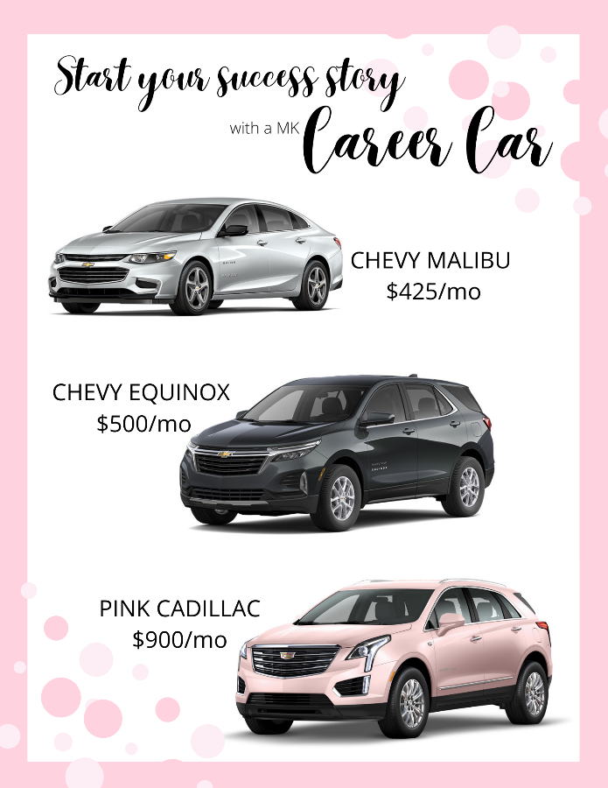
Advantages/Advancement: Mary Kay is not a get rich quick thing (that doesn't exist, right?) you get out of it what you put into it! Isn’t that exciting? Nothing else matters--education level, age, how long you've been in. It's so neat to see so many women from different backgrounds that are successful. We also have advantages like no quotas, no territories, tax deductions, free training/mentorship.
Be your own boss/flexibility: Most consultants do an average of 2-6 hours a week, which would be one appointment like this per week. It’s totally based on your goals! If you wanted to earn that first career car you're probably looking at around 10-15 hours per week. The point is that you don't need big chunks of time, you can weave it into what you're already doing!

Then say,
I have a 1-10 Survey Form that I would like for you to fill out (you can offer an incentive if you like for them to do so like $5 off their order. You can also tell them you have a goal to have X number of these filled out each week). “1” means I’d like to be a customer FOREVER and “10” means I’d love to start this business today, and “5” is cheating so that is why it’s not on the form! (lol)

